
NAME : TESALONIKA GRACE BENILA
NIM : 254107020198
CLASS : INFORMATICS ENGINEERING / TI - 2I
COURSE : PROGRAM BASE OBJECT
LECTURER : RIDWAN RISMANTO, S.ST., M.KOM., PH.D.
JOBSHEET WEEK 2 – CLASS AND OBJECT

EXPERIMENT

Experimental 1: Creating Class Diagram

Case study 1 :
In a company, one of the data that is processed is employee data. Each employee has an id, name, gender, title, title and salary. Each employee can also view personal data and see his salary.

1. Describe the class diagram design from case study 1 !,
Answer Case Study 1:
Employee
- id_employee : int
- name_employee : String
- gender_employee : String
- title : String
- salary : Double

+ viewPersonalData() : void
+ viewSalary() : double

2. Mention what classes can be made from case study 1 !,
Answer:
From that case study, class that we can made is : Employee
Because all the data and activity is told on the inside case study and it has a related with the Employee

3. Mention the attributes and data types that can be identified from each class from case study 1!
Answer:
Attribute | Data Type | Description
id | int | Employee identification number
name | String | Employee's name
gender | String | Employee's gender
title | String | Employee's job title/position
salary | double | Employee's salary

4. Mention the methods that you created from each class in case study 1!
There are two Methods that I creates from each class in this case study 1:
Method | Return Type | Description
viewPersonalData() | void | Displays the employee's personal data
viewSalary() | double | Displays/returns the employee's salary

Experimental 2: Create and accessing the member of a class

Case study 2 :
Look at the class diagram below. Make a program based on the class diagram!
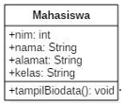
Saffolding :
1. Open the text editor/IDE ex: Notepad++ / Netbeans / VSCode
2. Write the code below:
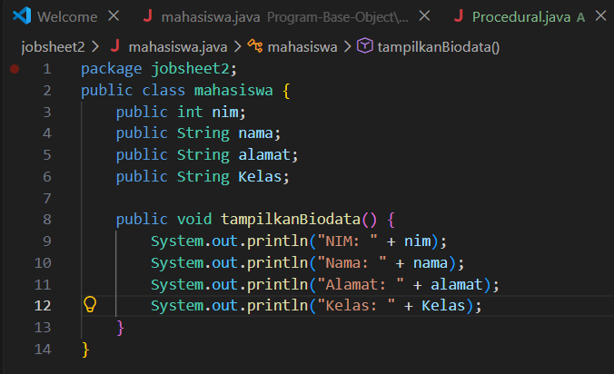

3. Save it into Mahasiswa.java.

4. To access the members of an object, the instance of the class must be created first. To show how to access the members of the Student class, let’s create a new file and then typing the following program code:
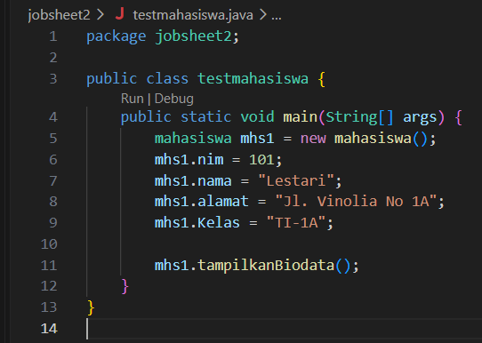
5. Save it into TestMahasiswa.java
6. Run the TestMahasiswa class
7. Based on the code, please explain in which line the attribute declaration was?
Answer :
The attribute declaration is located in the Mahasiswa class. The attributes are used to store the data of a student, such as nim, nama, and other student information.
8. Based on the code, please explain in which line the method declaration was?
Answer: the method declaration is located in the Mahasiswa class, specially it was showing in the method tampilkanBiodata()
9. How many objects instantiate from the code?
There is 1 object instantiated from the code, which is:
10. What does this line “mhs1.nim=101” mean?
It means that the nim attribute of the object mhs1 is assigned the value 101.
11. What does this line “mhs1.tampilBiodata()” do?
It calls the tampilBiodata() method belonging to the mhs1 object. The method is used to display the student's biodata.
12. Please instantiate 2 more object, by adding more code!
Two additional objects can be created as follows:
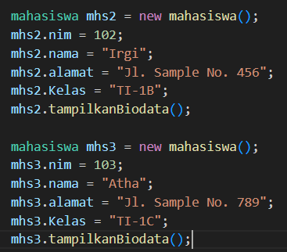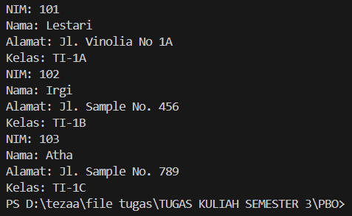

Experimental 3: Writing method that has a return value

Scaffolding :
1. Open the text editor/ IDE ex: Notepad ++ / netbeans.
2. Write the code below:
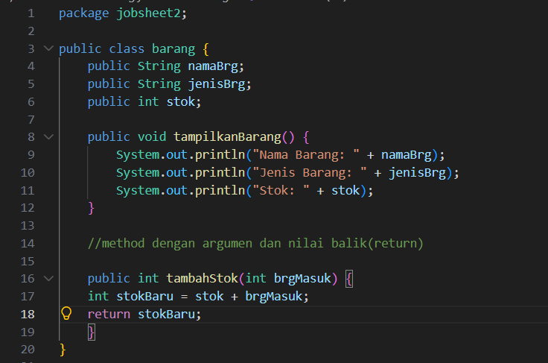
3. Save into Barang.java

1. To access the members of an object, the instance of the class must be created first. To show how to access the members of the barang class, let’s create a new file and then typing the following program code:
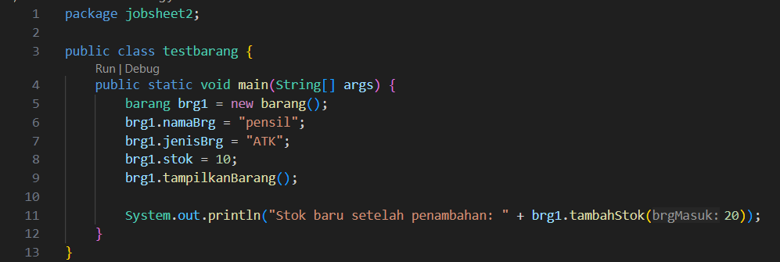
2. Save intoTestBarang.java
3. Run the code!
4. What is the function of an argument in a method?
Answer: An argument is a value that is passed to a method when the method is called. It is used to provide data that the method needs to perform a specific operation.
5. Makes conclusion on “return” keyword, when should we used it?
Answer : The return keyword is used to return a value from a method to the code that calls the method. We use return when a method needs to produce or send back a result.

Assignment:
1. One of the video game rental shops process is borrowing, The stored data when someone renting the game are the id, member name, game name, and the amount to pay. Each rent can display the data and the amount to pay. Make a class diagram based on the case study!
explanation:
• The price amount will be coming from price per day times renting duration!
• Assume that 1 transaction will only consist of 1 game.
Answer:
RENTAL
- id : int
- memberName : String
- gameName : String
- pricePerDay : Double
- rentingDuration : int
- amountTo Pay : double
+ calculatePayment() : double
+ displayData() : void

2. Create the code based on the case study no 1!
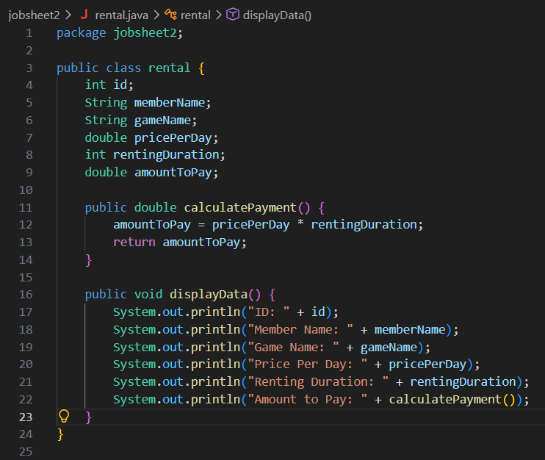
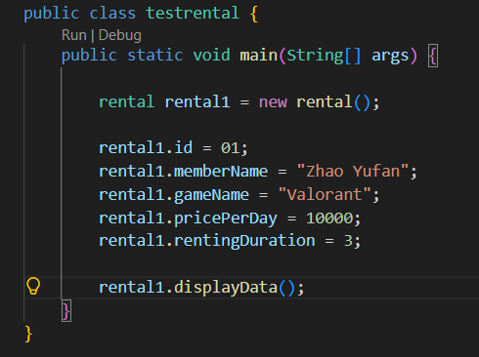
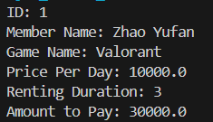

3. More exercise, please create the code from the following class diagram:
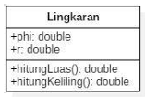
Answer:
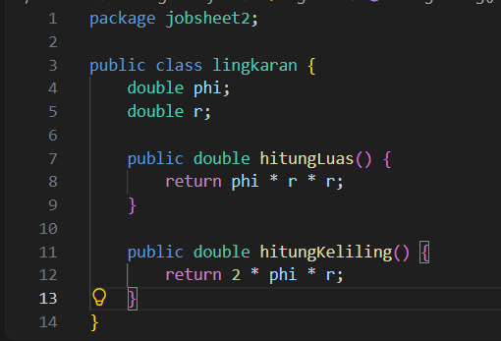

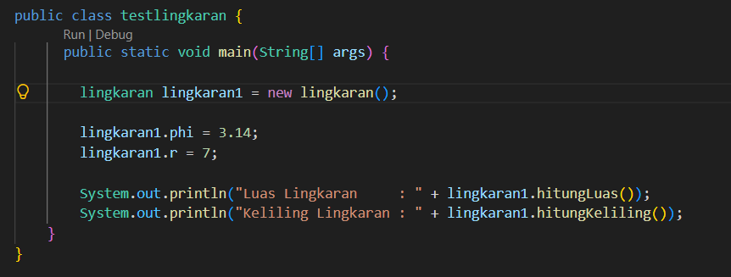
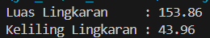

4. More exercise, please create the code from the following class diagram:
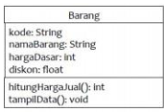
Description:
• The hargaDasar attribute is in Rupiah and the discount atribute in percentage!
• The hitungHargaJual() method used to calculate the based price by following this rule Selling price (hargaJual)= base price(hargaDasar) – (discount(diskon) x base price (hargaDasar))
• The tampilData() Method will be used to show the value of each class attribute:e kode, namaBarang, hargaDasar, diskon dan harga jual.

Answer :
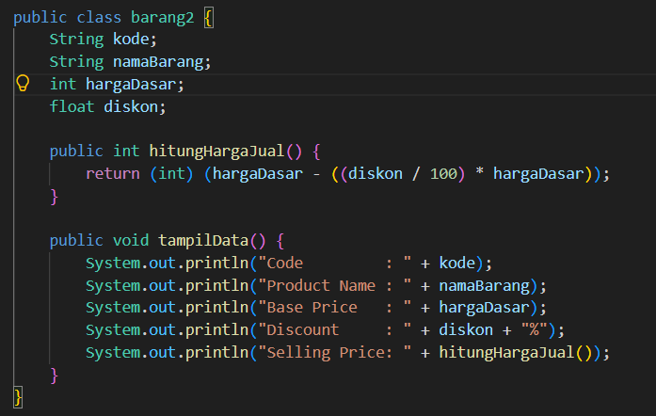
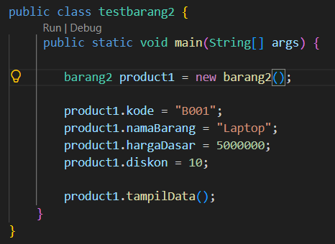
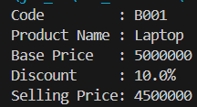

https://github.com/tezabae/Program-Base-Object/tree/83db344443bf829b5ed11e34c1be479c2a8f3903/jobsheet1

